Problem Set 4

SeungWha Lee

Xinyuan Meng

Boyang Pan

**Part 1: 30 Value-Weight Industry portfolios**

1. The table below summarizes the statistics of the 30 value-weighted industry portfolios.

|  |  |  |  |
| --- | --- | --- | --- |
| **Industry** | **Mean** | **Standard Deviation** | **Sharpe Ratio** |
| Food | 0.9778 | 4.7614 | 0.1470 |
| Beer | 1.2087 | 7.2452 | 0.1285 |
| Smoke | 1.1698 | 5.7979 | 0.1538 |
| Games | 1.1234 | 8.9731 | 0.0942 |
| Books | 0.9227 | 7.1970 | 0.0896 |
| Hshld | 0.9236 | 5.8481 | 0.1104 |
| Clths | 0.9248 | 6.1112 | 0.1058 |
| Hlth | 1.0799 | 5.5942 | 0.1433 |
| Chems | 1.0601 | 6.3346 | 0.1235 |
| Txtls | 1.0026 | 7.6750 | 0.0944 |
| Cnstr | 0.9392 | 6.9108 | 0.0957 |
| Steel | 0.9188 | 8.4729 | 0.0756 |
| FabPr | 1.0508 | 7.2501 | 0.1066 |
| ElcEq | 1.1723 | 7.6269 | 0.1173 |
| Autos | 1.0813 | 8.0051 | 0.1003 |
| Carry | 1.1254 | 7.6173 | 0.1112 |
| Mines | 0.9122 | 7.3175 | 0.0867 |
| Coal | 1.0742 | 10.8620 | 0.0733 |
| Oil | 1.0285 | 6.0951 | 0.1231 |
| Util | 0.8789 | 5.5496 | 0.1083 |
| Telcm | 0.8620 | 4.6019 | 0.1269 |
| Servs | 1.2051 | 8.3869 | 0.1105 |
| BusEq | 1.1155 | 6.7947 | 0.1233 |
| Paper | 1.0319 | 5.8925 | 0.1279 |
| Trans | 0.9279 | 7.1083 | 0.0914 |
| Whlsl | 0.8287 | 7.3691 | 0.0747 |
| Rtail | 1.0271 | 5.9903 | 0.1250 |
| Meals | 1.0577 | 6.5241 | 0.1195 |
| Fin | 1.0187 | 6.8279 | 0.1085 |
| Other | 0.8039 | 6.8061 | 0.0773 |

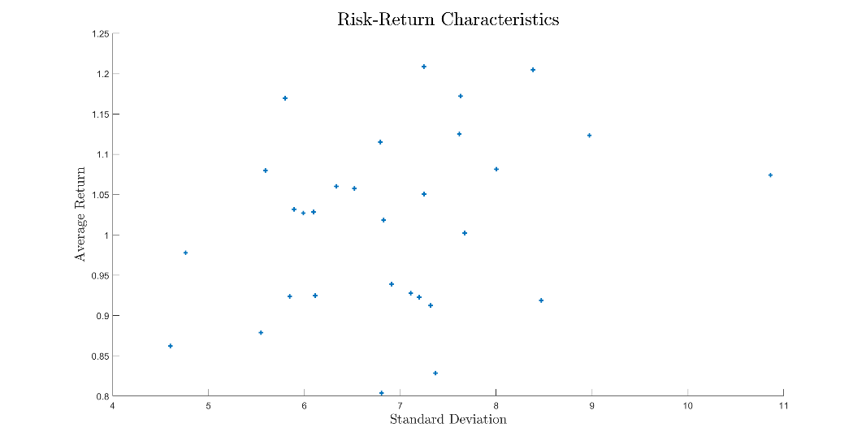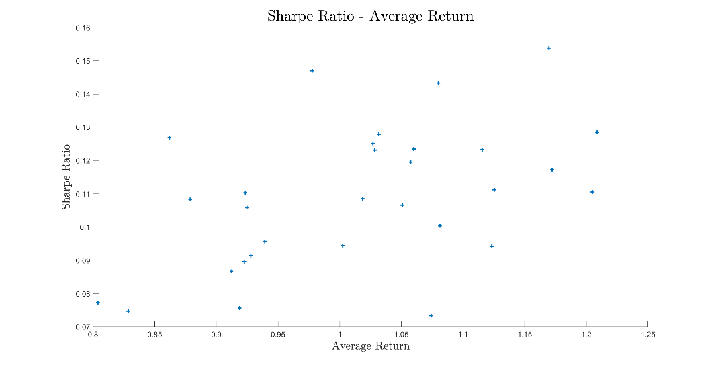The scatter plots below exhibit the *standard deviation – average return* and *average return – Sharpe Ratio* pairs of the 30 industry portfolios. As illustrated, we do not observe a discernible pattern.

1. The table below summarizes the time-series regression used to perform Gibbons-Ross-Shanken (GRS) test.

|  |  |  |  |  |  |
| --- | --- | --- | --- | --- | --- |
| **Industry** | **Intercept** | **Beta** | **Industry** | **Intercept** | **Beta** |
| Food | 0.2182 | 0.7394 | Carry | 0.0732 | 1.1887 |
| Beer | 0.3171 | 0.9421 | Mines | 0.0427 | 0.9082 |
| Smoke | 0.4822 | 0.6287 | Coal | -0.0505 | 1.2998 |
| Games | -0.0591 | 1.3886 | Oil | 0.1850 | 0.8681 |
| Books | -0.0770 | 1.1080 | Util | 0.0940 | 0.7783 |
| Hshld | 0.0578 | 0.9023 | Telcm | 0.1532 | 0.6615 |
| Clths | 0.1171 | 0.8132 | Servs | 0.3976 | 0.8128 |
| Hlth | 0.2553 | 0.8393 | BusEq | 0.1357 | 1.0775 |
| Chems | 0.1030 | 1.0426 | Paper | 0.1321 | 0.9545 |
| Txtls | -0.0173 | 1.1389 | Trans | -0.0912 | 1.1378 |
| Cnstr | -0.1024 | 1.1724 | Whlsl | -0.1587 | 1.0891 |
| Steel | -0.2431 | 1.3570 | Rtail | 0.1205 | 0.9650 |
| FabPr | -0.0360 | 1.2416 | Meals | 0.1638 | 0.9455 |
| ElcEq | 0.0579 | 1.2841 | Fin | -0.0193 | 1.1667 |
| Autos | -0.0122 | 1.2521 | Other | -0.1677 | 1.0648 |

**GRS F-statistic: 1.8895, p-value: 0.0028**

Based on the test statistic and the p-value, we should reject the null hypothesis that we cannot increase the Sharpe Ratio of the market portfolio by adding some combination of the risky assets (30 industry portfolios). That is, the portfolio used as the market proxy is not mean-variance efficient and the CAPM is rejected.

1. If we have T periods, N assets, and K factors, the test statistic of the GRS test is computed as:

$$\hat{W}=\frac{T}{N}×\frac{T-N-K}{T-K-1}×\frac{{\hat{α}}^{'}{\hat{Σ}}^{-1}\hat{α}}{1+{\hat{μ_{m}^{2}}}/{\hat{σ_{m}^{2}}}}$$

The null hypothesis of the test is:

$$H_{0}:\hat{W}=0 equivalently H_{0}: {\hat{α}}^{'}{\hat{Σ}}^{-1}\hat{α}=0 equivalently H_{0}: \hat{α}=0$$

where $\hat{α}=[\hat{α_{1}}, …, {\hat{α}}_{N}]'$.

That is, the null hypothesis states that we cannot improve the Sharpe Ratio of the portfolio by adding some combination of the set of N risky assets to the portfolio used as the market proxy. This is equivalent to arguing that CAPM is true, since, if the market proxy is mean-variance efficient, the model would correctly price the asset, and we would have a vector of intercepts with zeros, or, in other words, observe an alpha of zero.

The time-series regression here estimates the beta risk premium by regressing the excess return on each portfolio $r_{portfolio}-r_{f}$ against the excess return on the market, $r_{m}-r_{f}$.

1. The table below lists the estimated intercept, its t-stat and the p-values of the industry portfolios. The signs of the intercepts vary, with magnitudes less than 0.5. Yet, we observe that 3 of them – on Food, Smoke and Hlth – are statistically significant. In these industry portfolios, we can say that we have statistical evidence that CAPM has difficulty pricing them.

|  |  |  |  |  |  |  |  |
| --- | --- | --- | --- | --- | --- | --- | --- |
| **Industry** | **Intercept** | **t-stat** | **p-value** | **Industry** | **Intercept** | **t-stat** | **p-value** |
| **Food** | **0.2182** | **2.7185** | **0.0067** | Carry | 0.0732 | 0.5726 | 0.5670 |
| Beer | 0.3171 | 1.9954 | 0.0462 | Mines | 0.0427 | 0.2549 | 0.7988 |
| **Smoke** | **0.4822** | **3.3518** | **0.0008** | Coal | -0.0505 | -0.1982 | 0.8429 |
| Games | -0.0591 | -0.3860 | 0.6995 | Oil | 0.1850 | 1.5364 | 0.1247 |
| Books | -0.0770 | -0.6215 | 0.5344 | Util | 0.0940 | 0.8418 | 0.4001 |
| Hshld | 0.0578 | 0.5742 | 0.5659 | Telcm | 0.1532 | 1.7119 | 0.0872 |
| Clths | 0.1171 | 0.8932 | 0.3719 | Servs | 0.3976 | 1.8128 | 0.0701 |
| **Hlth** | **0.2553** | **2.5144** | **0.0121** | BusEq | 0.1357 | 1.2351 | 0.2171 |
| Chems | 0.1030 | 1.1272 | 0.2599 | Paper | 0.1321 | 1.4747 | 0.1406 |
| Txtls | -0.0173 | -0.1213 | 0.9034 | Trans | -0.0912 | -0.8171 | 0.4141 |
| Cnstr | -0.1024 | -1.1638 | 0.2448 | Whlsl | -0.1587 | -1.1544 | 0.2486 |
| Steel | -0.2431 | -1.8293 | 0.0676 | Rtail | 0.1205 | 1.3048 | 0.1922 |
| FabPr | -0.0360 | -0.4076 | 0.6837 | Meals | 0.1638 | 1.3020 | 0.1932 |
| ElcEq | 0.0579 | 0.5791 | 0.5627 | Fin | -0.0193 | -0.2313 | 0.8171 |
| Autos | -0.0122 | -0.0915 | 0.9271 | Other | -0.1677 | -1.4763 | 0.1402 |

**Part 2: 10 Past Return portfolios**

Repeat a):

The table below summarizes the statistics of the 10 past-return portfolios.

|  |  |  |  |
| --- | --- | --- | --- |
| **Past Return Portfolios** | **Mean** | **Standard Deviation** | **Sharpe Ratio** |
| Past Loser (1) | 0.3184 | 9.7899 | 0.0041 |
| 2 | 0.6991 | 8.0535 | 0.0523 |
| 3 | 0.7522 | 6.9883 | 0.0678 |
| 4 | 0.8774 | 6.3559 | 0.0943 |
| 5 | 0.8825 | 5.9518 | 0.1016 |
| 6 | 0.9358 | 5.8029 | 0.1133 |
| 7 | 1.0143 | 5.4951 | 0.1340 |
| 8 | 1.1172 | 5.3433 | 0.1570 |
| 9 | 1.1983 | 5.6280 | 0.1635 |
| Past Winner (10) | 1.5038 | 6.4857 | 0.1890 |

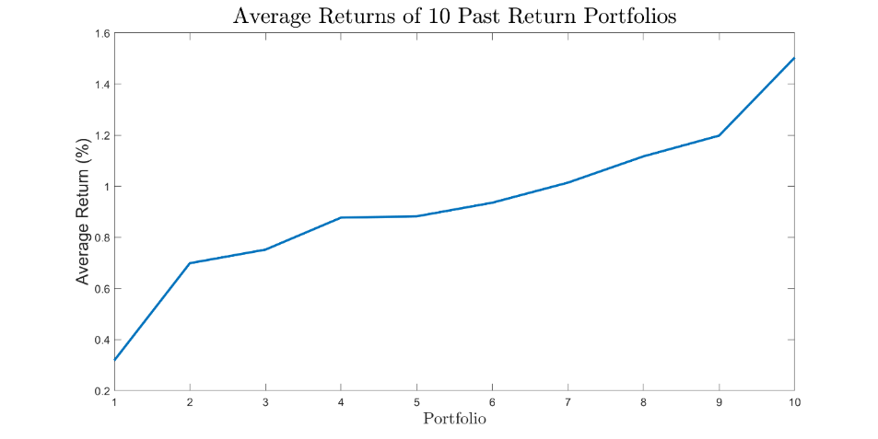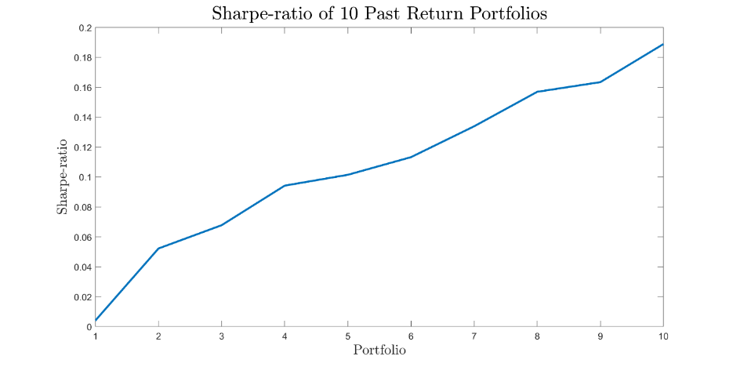The plots below exhibit the average returns and the Sharpe Ratios of the 10 portfolios lined up from past losers to past winners. As illustrated, we observe that past winners tend to continue performing well, while past losers continue to not do well. This may be attributed to the momentum factor, or just that firms that performed well in the past are the strong and healthy firms, so they simply continue to do better than the others.

Repeat b)

The table below summarizes the time-series regression used to perform Gibbons-Ross-Shanken (GRS) test.

|  |  |  |
| --- | --- | --- |
| **Past Return Portfolios** | **Intercept** | **Beta** |
| Past Loser (1) | -0.9690 | 1.5585 |
| 2 | -0.4394 | 1.3284 |
| 3 | -0.2874 | 1.1757 |
| 4 | -0.1089 | 1.0935 |
| 5 | -0.0681 | 1.0383 |
| 6 | -0.0100 | 1.0309 |
| 7 | 0.1082 | 0.9697 |
| 8 | 0.2341 | 0.9341 |
| 9 | 0.2956 | 0.9644 |
| Past Winner (10) | 0.5626 | 1.0238 |

**GRS F-statistic: 6.4758, p-value: 9.3276e-10**

Based on the test statistic and the p-value, we should reject the null hypothesis that we cannot increase the Sharpe Ratio of the market portfolio by adding some combination of the risky assets (all assets divided into the 10 bins based on their past performances). That is, the portfolio used as the market proxy is not mean-variance efficient and CAPM is rejected.

Repeat d)

|  |  |  |  |
| --- | --- | --- | --- |
| **Past Return Portfolios** | **Intercept** | **T-Stat** | **p-value** |
| **Past Loser (1)** | **-0.9690** | **-6.2215** | **0.0000** |
| **2** | **-0.4394** | **-3.8410** | **0.0001** |
| **3** | **-0.2874** | **-3.1441** | **0.0017** |
| 4 | -0.1089 | -1.4650 | 0.1432 |
| 5 | -0.0681 | -1.0664 | 0.2865 |
| 6 | -0.0100 | -0.1881 | 0.8509 |
| **7** | **0.1082** | **2.0055** | **0.0452** |
| **8** | **0.2341** | **4.1686** | **0.0000** |
| **9** | **0.2956** | **4.4012** | **0.0000** |
| **Past Winner (10)** | **0.5626** | **5.3425** | **0.0000** |

The signs of the intercepts tend to be negative for the past losers and positive for the past winners, with magnitudes small for the firms that performed mediocre in the past. We observe that the intercepts become more statistically significant for the group of firms in the two ends: past losers and past winners. In these portfolios, we can say that we have statistical evidence that CAPM has difficulty pricing them.

**Part 3: 25 Size and BE/ME portfolios**

1. Repeat a):

The table below summarizes the statistics of the 25 size-BE/ME portfolios.

|  |  |  |  |  |
| --- | --- | --- | --- | --- |
| **Size** | **BE/ME** | **Mean** | **Standard Deviation** | **Sharpe Ratio** |
| Small (1) | Low (1) | 0.8417 | 12.2542 | 0.0460 |
| Small (1) | 2 | 0.9699 | 9.8670 | 0.0701 |
| Small (1) | 3 | 1.2724 | 9.0129 | 0.1103 |
| Small (1) | 4 | 1.4614 | 8.3545 | 0.1416 |
| Small (1) | High (2) | 1.6424 | 9.3054 | 0.1466 |
| 2 | Low (1) | 0.8991 | 7.9958 | 0.0777 |
| 2 | 2 | 1.2041 | 7.5062 | 0.1234 |
| 2 | 3 | 1.2690 | 7.2675 | 0.1364 |
| 2 | 4 | 1.3575 | 7.4350 | 0.1452 |
| 2 | High (2) | 1.5345 | 8.7141 | 0.1442 |
| 3 | Low (1) | 0.9767 | 7.4143 | 0.0942 |
| 3 | 2 | 1.1845 | 6.4746 | 0.1400 |
| 3 | 3 | 1.2115 | 6.5183 | 0.1432 |
| 3 | 4 | 1.2970 | 6.9022 | 0.1476 |
| 3 | High (2) | 1.4362 | 8.5250 | 0.1359 |
| 4 | Low (1) | 0.9891 | 6.2624 | 0.1135 |
| 4 | 2 | 1.0262 | 6.0802 | 0.1231 |
| 4 | 3 | 1.1404 | 6.4230 | 0.1343 |
| 4 | 4 | 1.2483 | 6.8111 | 0.1424 |
| 4 | High (2) | 1.3118 | 8.7323 | 0.1184 |
| Big (5) | Low (1) | 0.8892 | 5.3460 | 0.1143 |
| Big (5) | 2 | 0.9045 | 5.3094 | 0.1180 |
| Big (5) | 3 | 0.9800 | 5.6455 | 0.1243 |
| Big (5) | 4 | 0.9293 | 6.6224 | 0.0983 |
| Big (5) | High (2) | 1.2383 | 8.5694 | 0.1121 |

The plots below exhibit the average returns and the Sharpe Ratios of the 25 portfolios lined up from Small-Low BE/ME ratio to Big-High BE/ME ratio. As illustrated, portfolios with high BE/ME ratios tend to have greater return and greater Sharpe Ratios. Moreover, smaller firms tend to exhibit higher returns, but when adjusted for their risk, they have lower Sharpe ratio. This is consistent with what Fama and French discovered in 1992.

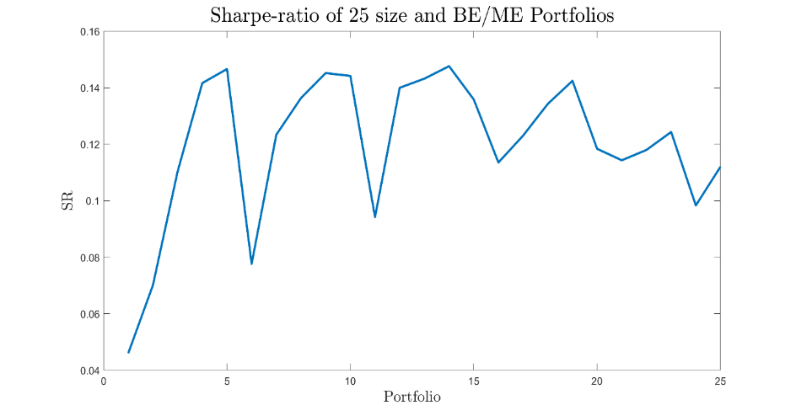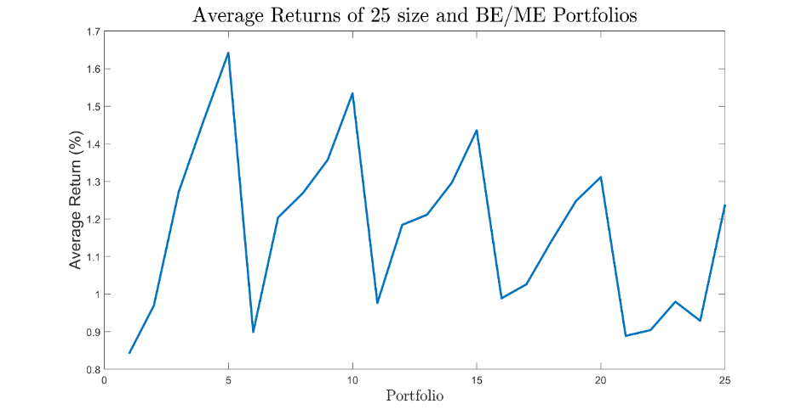

Repeat b)

The table below summarizes the time-series regression used to perform GRS test.

|  |  |  |  |
| --- | --- | --- | --- |
| **Size** | **BE/ME** | **Intercept** | **Beta** |
| Small (1) | Low (1) | -0.4981 | 1.6303 |
| Small (1) | 2 | -0.2259 | 1.4090 |
| Small (1) | 3 | 0.1002 | 1.3729 |
| Small (1) | 4 | 0.3566 | 1.2694 |
| Small (1) | High (2) | 0.4657 | 1.3798 |
| 2 | Low (1) | -0.2034 | 1.2659 |
| 2 | 2 | 0.1273 | 1.2264 |
| 2 | 3 | 0.2109 | 1.1977 |
| 2 | 4 | 0.2897 | 1.2125 |
| 2 | High (2) | 0.3585 | 1.3787 |
| 3 | Low (1) | -0.1123 | 1.2451 |
| 3 | 2 | 0.1733 | 1.1256 |
| 3 | 3 | 0.2015 | 1.1238 |
| 3 | 4 | 0.2636 | 1.1596 |
| 3 | High (2) | 0.2607 | 1.3779 |
| 4 | Low (1) | -0.0002 | 1.0919 |
| 4 | 2 | 0.0450 | 1.0797 |
| 4 | 3 | 0.1360 | 1.1153 |
| 4 | 4 | 0.2185 | 1.1541 |
| 4 | High (2) | 0.1086 | 1.4204 |
| Big (5) | Low (1) | -0.0111 | 0.9553 |
| Big (5) | 2 | 0.0078 | 0.9498 |
| Big (5) | 3 | 0.0713 | 0.9684 |
| Big (5) | 4 | -0.0707 | 1.1084 |
| Big (5) | High (2) | 0.1058 | 1.3119 |

**GRS F-statistic: 3.5368, p-value: 1.3515e-08**

Based on the test statistic and the p-value, we should reject the null hypothesis that we cannot increase the Sharpe Ratio of the market portfolio by adding some combination of the risky assets (all assets divided into a 5-by-5 bins based on their size and BE/ME ratio). That is, the portfolio used as the market proxy is not mean-variance efficient and CAPM is rejected.

Repeat d)

|  |  |  |  |  |
| --- | --- | --- | --- | --- |
| **Size** | **BE/ME** | **Intercept** | **t-stat** | **p-value** |
| Small (1) | Low (1) | -0.4981 | -1.8954 | 0.0583 |
| Small (1) | 2 | -0.2259 | -1.1644 | 0.2445 |
| Small (1) | 3 | 0.1002 | 0.6292 | 0.5294 |
| **Small (1)** | **4** | **0.3566** | **2.4041** | **0.0164** |
| **Small (1)** | **High (2)** | **0.4657** | **2.6941** | **0.0072** |
| 2 | Low (1) | -0.2034 | -1.5693 | 0.1169 |
| 2 | 2 | 0.1273 | 1.1477 | 0.2513 |
| **2** | **3** | **0.2109** | **2.0249** | **0.0431** |
| **2** | **4** | **0.2897** | **2.6271** | **0.0087** |
| **2** | **High (2)** | **0.3585** | **2.5400** | **0.0112** |
| 3 | Low (1) | -0.1123 | -1.1344 | 0.2569 |
| **3** | **2** | **0.1733** | **2.4126** | **0.0160** |
| **3** | **3** | **0.2015** | **2.6446** | **0.0083** |
| **3** | **4** | **0.2636** | **2.8741** | **0.0041** |
| **3** | **High (2)** | **0.2607** | **2.0074** | **0.0450** |
| 4 | Low (1) | -0.0002 | -0.0028 | 0.9977 |
| 4 | 2 | 0.0450 | 0.7854 | 0.4324 |
| 4 | 3 | 0.1360 | 1.8953 | 0.0583 |
| **4** | **4** | **0.2185** | **2.5107** | **0.0122** |
| 4 | High (2) | 0.1086 | 0.8326 | 0.4053 |
| Big (5) | Low (1) | -0.0111 | -0.2356 | 0.8137 |
| Big (5) | 2 | 0.0078 | 0.1705 | 0.8647 |
| Big (5) | 3 | 0.0713 | 1.0507 | 0.2936 |
| Big (5) | 4 | -0.0707 | -0.7950 | 0.4268 |
| Big (5) | High (2) | 0.1058 | 0.7071 | 0.4797 |

The signs of the intercepts tend to be positive for those with high BE/ME ratio. We observe that the intercepts become more statistically significant for the group of firms with high BE/ME ratio and mid-cap firms. In these portfolios, we can say that we have statistical evidence that CAPM has difficulty pricing them.

1. The table below summarizes the time-series regression used to perform GRS test.

|  |  |  |  |
| --- | --- | --- | --- |
| **Size** | **BE/ME** | **Intercept** | **Beta** |
| Small (1) | Low (1) | -0.0075 | 0.2221 |
| Small (1) | 2 | -0.0037 | 0.2705 |
| Small (1) | 3 | -0.0052 | 0.3887 |
| Small (1) | 4 | -0.0041 | 0.4618 |
| Small (1) | High (2) | -0.0049 | 0.5325 |
| 2 | Low (1) | -0.0063 | 0.2440 |
| 2 | 2 | -0.0045 | 0.3619 |
| 2 | 3 | -0.0037 | 0.3868 |
| 2 | 4 | -0.0031 | 0.4210 |
| 2 | High (2) | -0.0037 | 0.4900 |
| 3 | Low (1) | -0.0056 | 0.2739 |
| 3 | 2 | -0.0037 | 0.3539 |
| 3 | 3 | -0.0038 | 0.3645 |
| 3 | 4 | -0.0035 | 0.3976 |
| 3 | High (2) | -0.0028 | 0.4514 |
| 4 | Low (1) | -0.0042 | 0.2781 |
| 4 | 2 | -0.0044 | 0.2927 |
| 4 | 3 | -0.0035 | 0.3367 |
| 4 | 4 | -0.0033 | 0.3786 |
| 4 | High (2) | -0.0030 | 0.4031 |
| Big (5) | Low (1) | -0.0036 | 0.2390 |
| Big (5) | 2 | -0.0029 | 0.2447 |
| Big (5) | 3 | -0.0032 | 0.2742 |
| Big (5) | 4 | -0.0024 | 0.2542 |
| Big (5) | High (2) | -0.0035 | 0.3748 |

**GRS F-statistic: 1.1765e-04, p-value: 1**

Based on the test statistic and the p-value, we strongly fail to reject the null hypothesis that we cannot increase the Sharpe Ratio of the market portfolio by adding some combination of the risky assets (all assets divided into a 5-by-5 bins based on their size and BE/ME ratio).

This is not surprising since the target portfolio we used as the market proxy is the portfolio that has already obtained the maximum Sharpe Ratio using the 25 portfolios, by mathematical definition.

1. The table below summarizes the time-series regression used to perform GRS test.

|  |  |  |  |
| --- | --- | --- | --- |
| **Size** | **BE/ME** | **Intercept** | **Beta** |
| Small (1) | Low (1) | 0.1145 | 0.1977 |
| Small (1) | 2 | 0.1981 | 0.2173 |
| Small (1) | 3 | 0.2823 | 0.3133 |
| Small (1) | 4 | 0.3596 | 0.3625 |
| Small (1) | High (2) | 0.3666 | 0.4390 |
| 2 | Low (1) | 0.2002 | 0.1852 |
| 2 | 2 | 0.2749 | 0.2865 |
| 2 | 3 | 0.3202 | 0.2951 |
| 2 | 4 | 0.3629 | 0.3153 |
| 2 | High (2) | 0.3908 | 0.3809 |
| 3 | Low (1) | 0.2092 | 0.2154 |
| 3 | 2 | 0.3229 | 0.2567 |
| 3 | 3 | 0.3223 | 0.2689 |
| 3 | 4 | 0.3299 | 0.3031 |
| 3 | High (2) | 0.3669 | 0.3482 |
| 4 | Low (1) | 0.2539 | 0.2011 |
| 4 | 2 | 0.2702 | 0.2103 |
| 4 | 3 | 0.2699 | 0.2607 |
| 4 | 4 | 0.3275 | 0.2828 |
| 4 | High (2) | 0.3210 | 0.3136 |
| Big (5) | Low (1) | 0.1886 | 0.1859 |
| Big (5) | 2 | 0.2242 | 0.1770 |
| Big (5) | 3 | 0.2434 | 0.2018 |
| Big (5) | 4 | 0.2208 | 0.1894 |
| Big (5) | High (2) | 0.2725 | 0.3026 |

**GRS F-statistic: 2.6370, p-value: 2.3261e-05**

Based on the test statistic and the p-value, we should reject the null hypothesis that we cannot increase the Sharpe Ratio of the market portfolio by adding some combination of the risky assets (all assets divided into a 5-by-5 bins based on their size and BE/ME ratio). That is, the portfolio used as the market proxy is not mean-variance efficient and CAPM is rejected.

This is not surprising. As we have observed in the last problem set, this out-of-sample tangency portfolio constructed is quite different from the in-sample tangency portfolio. This is because (1) the weights on the assets oscillate between two values every other month, and (2) the weights computed through Markowitz optimization is very sensitive to slight changes in the inputs. Therefore, our out-of-sample tangency portfolio is not mean-variance efficient when we applies the optimal weights of the in-sample data to the out-of-sample data.

1. The table below summarizes the time-series regression used to perform GRS test.

|  |  |  |  |
| --- | --- | --- | --- |
| **Size** | **BE/ME** | **Intercept** | **Beta** |
| Small (1) | Low (1) | -0.3950 | 0.8788 |
| Small (1) | 2 | -0.0225 | 0.6548 |
| Small (1) | 3 | 0.2907 | 0.6450 |
| Small (1) | 4 | 0.5449 | 0.5852 |
| Small (1) | High (2) | 0.6584 | 0.6471 |
| 2 | Low (1) | -0.1237 | 0.6827 |
| 2 | 2 | 0.2256 | 0.6420 |
| 2 | 3 | 0.3153 | 0.6193 |
| 2 | 4 | 0.3875 | 0.6343 |
| 2 | High (2) | 0.5268 | 0.6688 |
| 3 | Low (1) | -0.0437 | 0.6805 |
| 3 | 2 | 0.1880 | 0.6586 |
| 3 | 3 | 0.2358 | 0.6395 |
| 3 | 4 | 0.3114 | 0.6485 |
| 3 | High (2) | 0.3688 | 0.7236 |
| 4 | Low (1) | -0.0653 | 0.7116 |
| 4 | 2 | 0.0097 | 0.6770 |
| 4 | 3 | 0.1363 | 0.6655 |
| 4 | 4 | 0.2387 | 0.6706 |
| 4 | High (2) | 0.2017 | 0.7627 |
| Big (5) | Low (1) | -0.1628 | 0.7094 |
| Big (5) | 2 | -0.1013 | 0.6671 |
| Big (5) | 3 | -0.0023 | 0.6456 |
| Big (5) | 4 | -0.0807 | 0.6709 |
| Big (5) | High (2) | 0.1740 | 0.7208 |

**GRS F-statistic: 3.6831, p-value: 3.8024e-09**

Based on the test statistic and the p-value, we should reject the null hypothesis that we cannot increase the Sharpe Ratio of the market portfolio by adding some combination of the risky assets (all assets divided into a 5-by-5 bins based on their size and BE/ME ratio). That is, the Markowitz-optimized 30-industry portfolio used as the market proxy is not mean-variance efficient and CAPM is rejected.

This is somewhat unexpected since we originally thought that the 30 industry portfolios well-represents the true market portfolio. It may be the case that the 30 portfolios were not sufficiently diversified, or each portfolio is not optimized with its assets inside.

1. The table below summarizes the time-series regression used to perform GRS test.

|  |  |  |  |
| --- | --- | --- | --- |
| **Size** | **BE/ME** | **Intercept** | **Beta** |
| Small (1) | Low (1) | -0.1860 | 0.4383 |
| Small (1) | 2 | -0.0017 | 0.4127 |
| Small (1) | 3 | 0.4200 | 0.3444 |
| Small (1) | 4 | 0.5683 | 0.3618 |
| Small (1) | High (2) | 0.7881 | 0.3363 |
| 2 | Low (1) | -0.1799 | 0.4669 |
| 2 | 2 | 0.2306 | 0.4105 |
| 2 | 3 | 0.3082 | 0.4003 |
| 2 | 4 | 0.4368 | 0.3824 |
| 2 | High (2) | 0.5732 | 0.3977 |
| 3 | Low (1) | -0.0587 | 0.4476 |
| 3 | 2 | 0.1389 | 0.4470 |
| 3 | 3 | 0.2462 | 0.4059 |
| 3 | 4 | 0.3450 | 0.3888 |
| 3 | High (2) | 0.4626 | 0.4080 |
| 4 | Low (1) | -0.1081 | 0.4775 |
| 4 | 2 | 0.0233 | 0.4227 |
| 4 | 3 | 0.1573 | 0.4128 |
| 4 | 4 | 0.2944 | 0.3940 |
| 4 | High (2) | 0.2892 | 0.4361 |
| Big (5) | Low (1) | -0.1161 | 0.4242 |
| Big (5) | 2 | -0.0764 | 0.4042 |
| Big (5) | 3 | 0.0672 | 0.3710 |
| Big (5) | 4 | 0.0103 | 0.3702 |
| Big (5) | High (2) | 0.2988 | 0.3876 |

**GRS F-statistic: 3.3203, p-value: 8.6609e-08**

Based on the test statistic and the p-value, we should reject the null hypothesis that we cannot increase the Sharpe Ratio of the market portfolio by adding some combination of the risky assets (all assets divided into a 5-by-5 bins based on their size and BE/ME ratio). That is, the Markowitz-optimized 30-industry portfolio used as the market proxy is not mean-variance efficient and CAPM is rejected.

This is, again, somewhat unexpected since we originally thought that the 10 portfolios grouped by their past performances contain all the assets in the market, and therefore well-represent the true market portfolio. It may be the case that the each group is not optimized to have the maximum Sharpe Ratio, and therefore the optimized portfolio using the 10 groups is not mean-variance efficient.

1. The table below exhibits the correlations between the three tangency portfolios constructed by 30 value-weighted industry groups, 10 past performance groups, and 25 size-BE/ME ratio groups. As we can see, the correlations between the tangency portfolios are quite small. This is consistent with the results we observed in the previous questions. If they all well-represented the market portfolios, and GRS tests not rejected, they would have a high correlation, since theoretically, they should be the same. Yet, since we observed the opposite above, it makes sense to have such low correlations.

|  |  |  |  |
| --- | --- | --- | --- |
|  | 30 VW Industries | 10 past return portfolios | 25 size and BE/ME portfolios |
| 30 VW Industries | 1 | 0.3690 | 0.2258 |
| 10 past return portfolios | 0.3690 | 1 | 0.2436 |
| 25 size and BE/ME portfolios | 0.2258 | 0.2436 | 1 |